Web Application Development Lab 05 Report
  - Student Name: Vũ Quốc Khánh
Student ID: ITCSIU24039

Exercise 1

Task 1.1
Verification result after creating “users” table using DESCRIBE users:
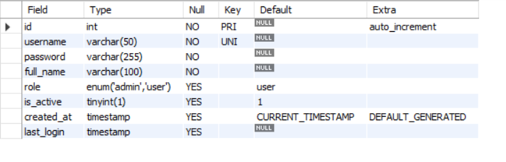

Task 1.2
Result after setting up BCrypt and run Java code provided by the document:
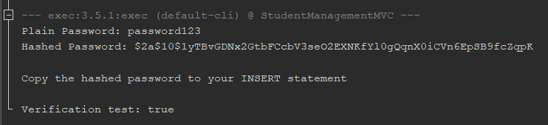
The generated hash is: $2a$10$1yTBvGDNx2GtbFCcbV3seO2EXNKfYl0gQqnX0iCVn6EpSB9fcZqpK

Task 1.3

SQL Code
INSERT INTO users (username, password, full_name, role) VALUES
('admin', '$2a$10$1yTBvGDNx2GtbFCcbV3seO2EXNKfYl0gQqnX0iCVn6EpSB9fcZqpK', 'Admin User', 'admin'),
('john', '$2a$10$1yTBvGDNx2GtbFCcbV3seO2EXNKfYl0gQqnX0iCVn6EpSB9fcZqpK', 'John Doe', 'user'),
('jane', '$2a$10$1yTBvGDNx2GtbFCcbV3seO2EXNKfYl0gQqnX0iCVn6EpSB9fcZqpK', 'Jane Smith', 'user');

Verification Result

Exercise 2

Task 2.1
package model;

import java.sql.Timestamp;

public class User {
private int id;
private String username, password, fullName, role;
private boolean isActive;
private Timestamp createdAt, lastLogin;

public User() {}

public User(String username, String password, String fullName, String role) {
this.username = username;
this.password = password;
this.fullName = fullName;
this.role = role;
}

public int getId() {
return id;
}

public void setId(int id) {
this.id = id;
}

public String getUsername() {
return username;
}

public void setUsername(String username) {
this.username = username;
}

public String getPassword() {
return password;
}

public void setPassword(String password) {
this.password = password;
}

public String getFullName() {
return fullName;
}

public void setFullName(String fullName) {
this.fullName = fullName;
}

public String getRole() {
return role;
}

public void setRole(String role) {
this.role = role;
}

public boolean isActive() {
return isActive;
}

public void setIsActive(boolean isActive) {
this.isActive = isActive;
}

public Timestamp getCreatedAt() {
return createdAt;
}

public void setCreatedAt(Timestamp createdAt) {
this.createdAt = createdAt;
}

public Timestamp getLastLogin() {
return lastLogin;
}

public void setLastLogin(Timestamp lastLogin) {
this.lastLogin = lastLogin;
}

public boolean isAdmin() {
return this.role == "admin";
}

public boolean isUser() {
return this.role == "user";
}

@Override
public String toString() {
return "User{" + "id=" + id + ", username=" + username + ", password=" + password + ", fullName=" + fullName + ", role=" + role + ", isActive=" + isActive + ", createdAt=" + createdAt + ", lastLogin=" + lastLogin + '}';
}
}

Task 2.2

Code
package dao;

import model.User;
import org.mindrot.jbcrypt.BCrypt;
import java.sql.*;

public class UserDAO {
private static final String DB_URL = "jdbc:mysql://localhost:3306/student_management";
private static final String DB_USER = "root";
private static final String DB_PASSWORD = "Q@jaP*96T8xY#2^7&3@7";

// TODO: SQL queries constants
private static final String SQL_AUTHENTICATE =
"SELECT * FROM users WHERE username = ? AND is_active = TRUE";

private static final String SQL_UPDATE_LAST_LOGIN =
"UPDATE users SET last_login = NOW() WHERE id = ?";

private static final String SQL_GET_BY_ID =
"SELECT * FROM users WHERE id = ?";

/**
* Connect to the database
* @return Connection object if successful
* @throws SQLException on database error
*/
private Connection getConnection() throws SQLException {
try {
Class.forName("com.mysql.cj.jdbc.Driver");
return DriverManager.getConnection(DB_URL, DB_USER, DB_PASSWORD);
} catch (ClassNotFoundException e) {
throw new SQLException("MySQL Driver not found", e);
}
}

/**
* Authenticate user with username and password
* @return User object if successful, null otherwise
* @throws SQLException on database error
*/
public User authenticate(String username, String password) {
User user = null;

try (
Connection conn = getConnection();
PreparedStatement authStmt = conn.prepareStatement(SQL_AUTHENTICATE);
) {
authStmt.setString(1, username);

ResultSet rs = authStmt.executeQuery();

// User found in the databse
while (rs.next()) {
// Verify user password
String hashedPassword = rs.getString("password");

// Valid password
if (BCrypt.checkpw(password, hashedPassword)) {
user = mapResultSetToUser(rs);
updateLastLogin(user.getId());
}
}
} catch (SQLException e) {
throw new Error("Database error: " + e.getMessage());
}

return user;
}

// Update user's last login when authentication successful
private void updateLastLogin(int userId) {
try (
Connection conn = getConnection();
PreparedStatement pstmt = conn.prepareStatement(SQL_UPDATE_LAST_LOGIN);
) {
pstmt.setInt(1, userId);
pstmt.executeUpdate();
} catch (SQLException e) {
throw new Error("Database error: " + e.getMessage());
}
}

// Query user by id
public User getUserById(int id) {
User user = null;
try (
Connection conn = getConnection();
PreparedStatement pstmt = conn.prepareStatement(SQL_GET_BY_ID);
) {
pstmt.setInt(1, id);

ResultSet rs = pstmt.executeQuery();

// User found in the database
while (rs.next()) {
return mapResultSetToUser(rs);
}
} catch (SQLException e) {
throw new Error("Database error: " + e.getMessage());
}

return user;
}

private User mapResultSetToUser(ResultSet rs) throws SQLException {
User user = new User(
rs.getString("username"),
rs.getString("password"),
rs.getString("full_name"),
rs.getString("role")
);

user.setId(rs.getInt("id"));
user.setIsActive(rs.getBoolean("is_active"));
user.setCreatedAt(rs.getTimestamp("created_at"));
user.setLastLogin(rs.getTimestamp("last_login"));

return user;
}

// Add this main method to test (remove after testing)
public static void main(String[] args) {
UserDAO dao = new UserDAO();

// Test authentication
User user = dao.authenticate("admin", "password123");
if (user != null) {
System.out.println("Authentication successful!");
System.out.println(user);
} else {
System.out.println("Authentication failed!");
}

// Test with wrong password
User invalidUser = dao.authenticate("admin", "wrongpassword");
System.out.println("Invalid auth: " + (invalidUser == null ? "Correctly rejected" : "ERROR!"));
}
}

Testing Result
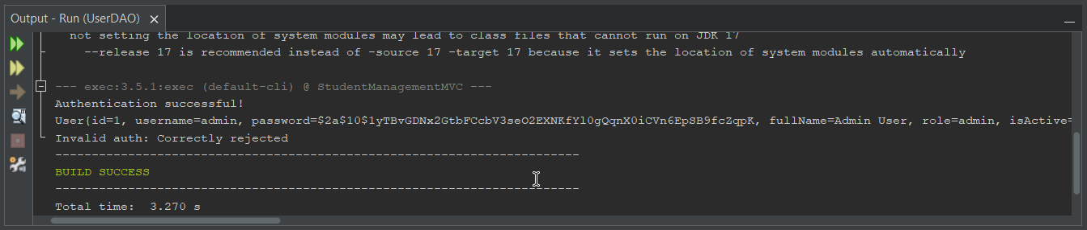

Exercise 3

Task 3.1
package controller;

import dao.UserDAO;
import model.User;
import jakarta.servlet.ServletException;
import jakarta.servlet.annotation.WebServlet;
import jakarta.servlet.http.*;
import java.io.IOException;

@WebServlet("/login")
public class LoginController extends HttpServlet {
private UserDAO userDAO;

@Override
public void init() {
this.userDAO = new UserDAO();
}

/**
* Display login page
*/
@Override
protected void doGet(HttpServletRequest request, HttpServletResponse response)
throws ServletException, IOException {
HttpSession session = request.getSession(false);

if (session != null && session.getAttribute("user") != null) {
// Already logged in, redirect to dashboard
response.sendRedirect("dashboard");
return;
}

request.getRequestDispatcher("/views/login.jsp").forward(request, response);
}

/**
* Process login form
*/
@Override
protected void doPost(HttpServletRequest request, HttpServletResponse response)
throws ServletException, IOException {
String username = request.getParameter("username");
String password = request.getParameter("password");

// Check required fields
if (username == null || username.trim().isEmpty() ||
password == null || password.trim().isEmpty()) {
// Set error and forward back to login
request.setAttribute("error", "Username and password are required");
request.getRequestDispatcher("/views/login.jsp").forward(request, response);
return;
}

User user = userDAO.authenticate(username, password);

// Authentication successful
if (user != null) {
// Invalidate older session if exists (security reasons)
HttpSession oldSession = request.getSession(false);

if (oldSession != null) {
oldSession.invalidate();
}

// Create new session and store user info
HttpSession newSession = request.getSession(true);
newSession.setAttribute("user", user);
newSession.setAttribute("role", user.getRole());
newSession.setAttribute("fullName", user.getFullName());

int timeoutInMinutes = 30 * 60;
newSession.setMaxInactiveInterval(timeoutInMinutes);

if (user.isAdmin()) {
response.sendRedirect("dashboard");
} else {
response.sendRedirect("student?action=list");
}
} else {
// Authentication failed
request.setAttribute("error", "Invalid username or password");
request.setAttribute("username", username); // Keep username in form
request.getRequestDispatcher("/views/login.jsp").forward(request, response);
}
}
}

Task 3.2
package controller;

import jakarta.servlet.ServletException;
import jakarta.servlet.annotation.WebServlet;
import jakarta.servlet.http.*;
import java.io.IOException;

@WebServlet("/logout")
public class LogoutController extends HttpServlet {
@Override
protected void doGet(HttpServletRequest request, HttpServletResponse response)
throws ServletException, IOException {
HttpSession session = request.getSession(false);

if (session != null) {
session.invalidate();
}

response.sendRedirect("login?message=Log out successfully");
}

@Override
protected void doPost(HttpServletRequest request, HttpServletResponse response)
throws ServletException, IOException {
doGet(request, response);
}
}

Exercise 4

Task 4.1

Code
<%@ page language="java" contentType="text/html; charset=UTF-8" pageEncoding="UTF-8"%>
<%@ taglib uri="http://java.sun.com/jsp/jstl/core" prefix="c" %>
<!DOCTYPE html>
<html>
<head>
<meta charset="UTF-8">
<meta name="viewport" content="width=device-width, initial-scale=1.0">
<title>Login - Student Management System</title>
<style>
* {
margin: 0;
padding: 0;
box-sizing: border-box;
}

body {
font-family: 'Segoe UI', Tahoma, Geneva, Verdana, sans-serif;
background: linear-gradient(135deg, #667eea 0%, #764ba2 100%);
min-height: 100vh;
display: flex;
justify-content: center;
align-items: center;
}

.login-container {
background: white;
padding: 40px;
border-radius: 10px;
box-shadow: 0 10px 40px rgba(0,0,0,0.2);
width: 100%;
max-width: 400px;
}

.login-header {
text-align: center;
margin-bottom: 30px;
}

.login-header h1 {
color: #333;
font-size: 28px;
margin-bottom: 10px;
}

.login-header p {
color: #666;
font-size: 14px;
}

.form-group {
margin-bottom: 20px;
}

.form-group label {
display: block;
margin-bottom: 5px;
color: #333;
font-weight: 500;
}

.form-group input[type="text"],
.form-group input[type="password"] {
width: 100%;
padding: 12px;
border: 1px solid #ddd;
border-radius: 5px;
font-size: 14px;
transition: border-color 0.3s;
}

.form-group input:focus {
outline: none;
border-color: #667eea;
}

.remember-me {
display: flex;
align-items: center;
margin-bottom: 20px;
}

.btn-login {
width: 100%;
padding: 12px;
background: linear-gradient(135deg, #667eea 0%, #764ba2 100%);
color: white;
border: none;
border-radius: 5px;
font-size: 16px;
font-weight: 600;
cursor: pointer;
transition: transform 0.2s;
}

.btn-login:hover {
transform: translateY(-2px);
}

.alert {
padding: 12px;
border-radius: 5px;
margin-bottom: 20px;
font-size: 14px;
}

.alert-error {
background: #fee;
color: #c33;
border: 1px solid #fcc;
}

.alert-success {
background: #efe;
color: #3c3;
border: 1px solid #cfc;
}

.demo-credentials {
margin-top: 20px;
padding: 15px;
background: #f8f9fa;
border-radius: 5px;
font-size: 12px;
}

.demo-credentials h4 {
margin-bottom: 10px;
color: #333;
}

.demo-credentials p {
margin: 5px 0;
color: #666;
}
</style>
</head>
<body>
<div class="login-container">
<div class="login-header">
<h1>🔐 Login</h1>
<p>Student Management System</p>
</div>

<!-- Error Message -->
<c:if test="${not empty error}">
<div class="alert alert-error">
❌ ${error}
</div>
</c:if>

<!-- Success Message -->
<c:if test="${not empty param.message}">
<div class="alert alert-success">
✅ ${param.message}
</div>
</c:if>

<!-- Login Form -->
<form action="login" method="post">
<div class="form-group">
<label for="username">Username</label>
<input type="text"
id="username"
name="username"
value="${username}"
placeholder="Enter your username"
required
autofocus>
</div>

<div class="form-group">
<label for="password">Password</label>
<input type="password"
id="password"
name="password"
placeholder="Enter your password"
required>
</div>

<button type="submit" class="btn-login">Login</button>
</form>

<!-- Demo Credentials -->
<div class="demo-credentials">
<h4>Demo Credentials:</h4>
<p><strong>Admin:</strong> username: admin / password: password123</p>
<p><strong>User:</strong> username: john / password: password123</p>
</div>
</div>
</body>
</html>

Result
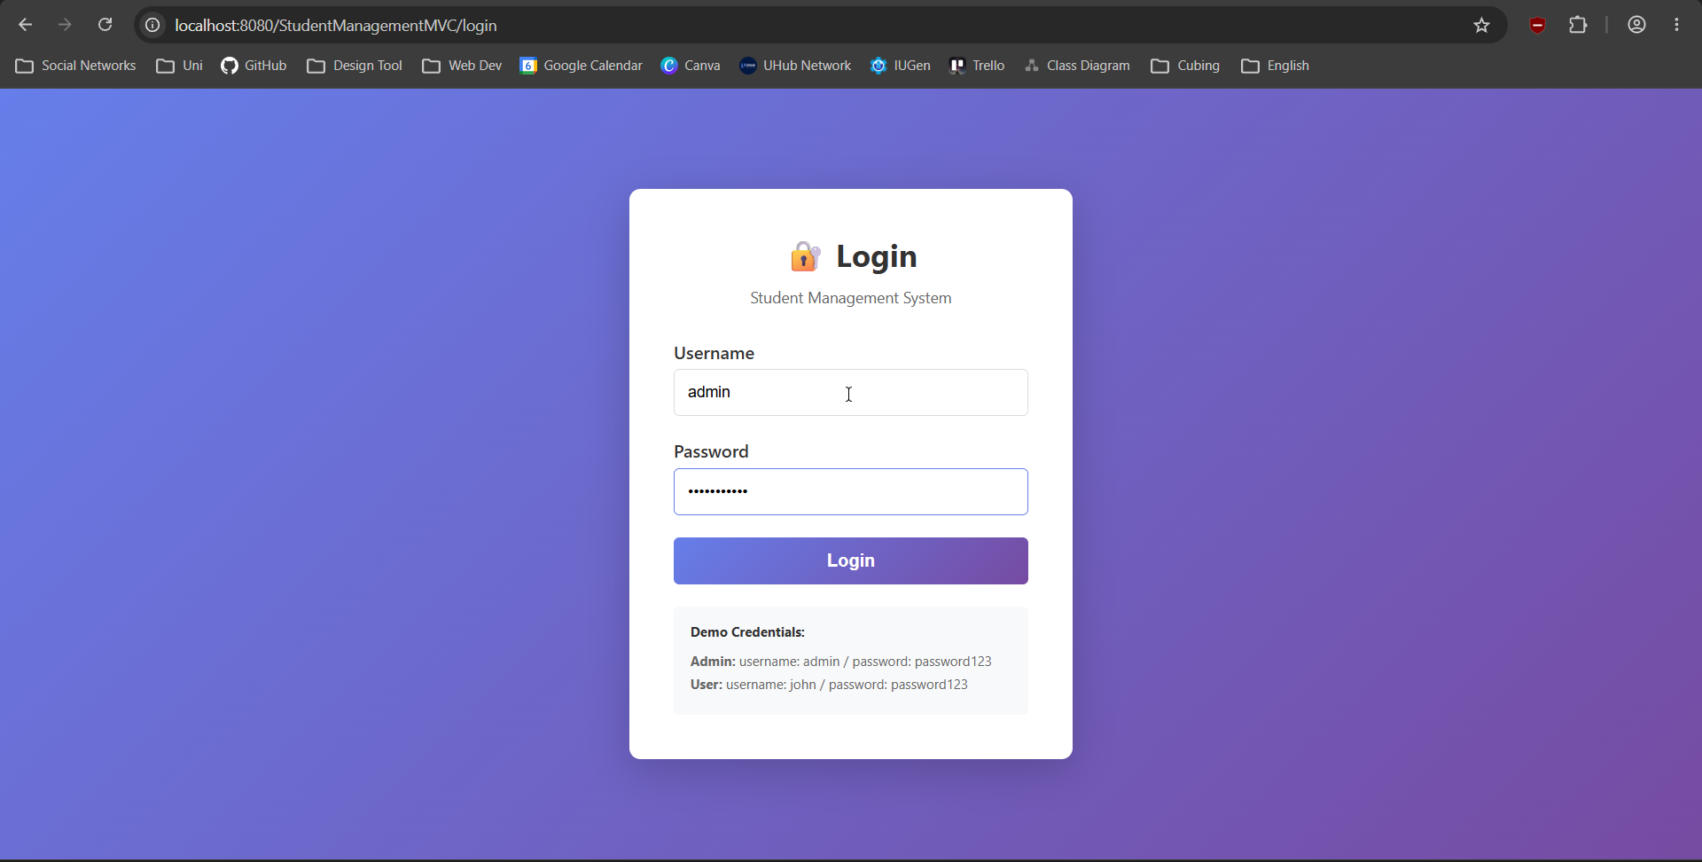

Task 4.2

DashboardController.java
package controller;

import dao.StudentDAO;
import model.User;
import jakarta.servlet.ServletException;
import jakarta.servlet.annotation.WebServlet;
import jakarta.servlet.http.*;
import java.io.IOException;

@WebServlet("/dashboard")
public class DashboardController extends HttpServlet {
private StudentDAO studentDAO;

@Override
public void init() {
this.studentDAO = new StudentDAO();
}

@Override
protected void doGet(HttpServletRequest request, HttpServletResponse response)
throws ServletException, IOException {
HttpSession session = request.getSession(false);

if (session == null || session.getAttribute("user") == null) {
response.sendRedirect("login");
return;
}

User user = (User) session.getAttribute("user");

request.setAttribute("totalStudents", studentDAO.getTotalStudents());
request.setAttribute("welcomeMessage", "Welcome back, " + user.getFullName() + "!");

// Forward to dashboard
request.getRequestDispatcher("/views/dashboard.jsp").forward(request, response);
}
}

dashboard.jsp
<%@ page language="java" contentType="text/html; charset=UTF-8" pageEncoding="UTF-8"%>
<%@ taglib uri="http://java.sun.com/jsp/jstl/core" prefix="c" %>
<!DOCTYPE html>
<html>
<head>
<meta charset="UTF-8">
<title>Dashboard</title>
<style>
* {
margin: 0;
padding: 0;
box-sizing: border-box;
}

body {
font-family: 'Segoe UI', Tahoma, Geneva, Verdana, sans-serif;
background: #f5f5f5;
}

.navbar {
background: #2c3e50;
color: white;
padding: 15px 30px;
display: flex;
justify-content: space-between;
align-items: center;
}

.navbar h2 {
font-size: 20px;
}

.navbar-right {
display: flex;
align-items: center;
gap: 20px;
}

.user-info {
display: flex;
align-items: center;
gap: 10px;
}

.role-badge {
padding: 4px 12px;
border-radius: 12px;
font-size: 12px;
font-weight: 600;
}

.role-admin {
background: #e74c3c;
}

.role-user {
background: #3498db;
}

.btn-logout {
padding: 8px 20px;
background: #e74c3c;
color: white;
text-decoration: none;
border-radius: 5px;
font-size: 14px;
transition: background 0.3s;
}

.btn-logout:hover {
background: #c0392b;
}

.container {
max-width: 1200px;
margin: 30px auto;
padding: 0 20px;
}

.welcome-card {
background: white;
padding: 30px;
border-radius: 10px;
box-shadow: 0 2px 10px rgba(0,0,0,0.1);
margin-bottom: 30px;
}

.welcome-card h1 {
color: #2c3e50;
margin-bottom: 10px;
}

.welcome-card p {
color: #7f8c8d;
}

.stats-grid {
display: grid;
grid-template-columns: repeat(auto-fit, minmax(250px, 1fr));
gap: 20px;
margin-bottom: 30px;
}

.stat-card {
background: white;
padding: 25px;
border-radius: 10px;
box-shadow: 0 2px 10px rgba(0,0,0,0.1);
display: flex;
align-items: center;
gap: 20px;
}

.stat-icon {
font-size: 40px;
width: 60px;
height: 60px;
display: flex;
align-items: center;
justify-content: center;
border-radius: 10px;
}

.stat-icon-students {
background: #e8f4fd;
}

.stat-content h3 {
font-size: 28px;
color: #2c3e50;
margin-bottom: 5px;
}

.stat-content p {
color: #7f8c8d;
font-size: 14px;
}

.quick-actions {
background: white;
padding: 30px;
border-radius: 10px;
box-shadow: 0 2px 10px rgba(0,0,0,0.1);
}

.quick-actions h2 {
color: #2c3e50;
margin-bottom: 20px;
}

.action-grid {
display: grid;
grid-template-columns: repeat(auto-fit, minmax(200px, 1fr));
gap: 15px;
}

.action-btn {
padding: 20px;
background: #3498db;
color: white;
text-decoration: none;
border-radius: 8px;
text-align: center;
transition: all 0.3s;
display: block;
}

.action-btn:hover {
background: #2980b9;
transform: translateY(-2px);
}

.action-btn-primary {
background: #3498db;
}

.action-btn-success {
background: #27ae60;
}

.action-btn-warning {
background: #f39c12;
}
</style>
</head>
<body>
<!-- Navigation Bar -->
<div class="navbar">
<h2>📚 Student Management System</h2>
<div class="navbar-right">
<div class="user-info">
<span>${sessionScope.fullName}</span>
<span class="role-badge role-${sessionScope.role}">
${sessionScope.role}
</span>
</div>
<a href="logout" class="btn-logout">Logout</a>
</div>
</div>

<!-- Main Content -->
<div class="container">
<!-- Welcome Card -->
<div class="welcome-card">
<h1>${welcomeMessage}</h1>
<p>Here's what's happening with your students today.</p>
</div>

<!-- Statistics -->
<div class="stats-grid">
<div class="stat-card">
<div class="stat-icon stat-icon-students">
👨‍🎓
</div>
<div class="stat-content">
<h3>${totalStudents}</h3>
<p>Total Students</p>
</div>
</div>
</div>

<!-- Quick Actions -->
<div class="quick-actions">
<h2>Quick Actions</h2>
<div class="action-grid">
<a href="student?action=list" class="action-btn action-btn-primary">
📋 View All Students
</a>

<c:if test="${sessionScope.role eq 'admin'}">
<a href="student?action=new" class="action-btn action-btn-success">
➕ Add New Student
</a>
</c:if>

<a href="student?action=search" class="action-btn action-btn-warning">
🔍 Search Students
</a>
</div>
</div>
</div>
</body>
</html>

Result
Logging in as “admin” redirect the web browser to the dashboard:
